**Discovery Report**

ORIENT COMMERCIAL BANK

Volume 14 - Cash by Code

Way4 Implementation

|  |  |
| --- | --- |
| Prepared for : | ORIENT COMMERCIAL BANK |
| Version of Document : | 1.0 |
| Status : | Draft |
| Release Date : | 9th Jun 2018 |
| Prepared by : | Openway Asia |
| Author : |  |
| Owner : | Openway Asia |

# History of Changes

|  |  |  |  |  |
| --- | --- | --- | --- | --- |
| **Version** | **Date** | **Description** | **Author** | **Approved By** |
| 1.0 | 09.06.2018 | Initial Version. | Tu B. Nguyen |  |
|  |  |  |  |  |
|  |  |  |  |  |
|  |  |  |  |  |
|  |  |  |  |  |
|  |  |  |  |  |
|  |  |  |  |  |
|  |  |  |  |  |

Copyright

© OpenWay International Limited 2018. All rights reserved.

The Copyright of this complete document and every part it belongs to OpenWay International Limited. Proprietary material, brand or product names of other parties or trademarks remain with their respective owners. You may not, except with our express written permission, distribute or commercially exploit the content. Nor may you transmit it or store it in any other website or other form of electronic retrieval system. Any sample data used in examples below are completely fictitious unless otherwise noted.

Disclaimer

This document and the OpenWay International software it describes are furnished by OpenWay International Limited under a Software Licensing Agreement, Consultancy Agreement, Variation Request or Confidentiality Agreement, and may be used or copied only in accordance with the terms of such Agreement. Neither this document nor the OpenWay International software it describes may be used, sold, transferred, copied, translated, reproduced or transmitted in any form or by any means, electronic or mechanical, for any purpose, in whole or in part, other than in accordance with the terms of such Agreement, or otherwise without prior written consent of OpenWay International Limited.

This document describes a generic product or service and should be read in conjunction with other documents relevant to the configuration of any specific system. The licensee of OpenWay software or user of OpenWay International services is responsible for ensuring that the product or service described herein meets its own requirements. The information contained in this document is subject to change without notice and should not be taken as a commitment by OpenWay International Limited. OpenWay International Limited assumes no responsibility for any errors that may appear in this document.

Confidentiality

The information contained in this Document is the property of OpenWay International Ltd and contains CONFIDENTIAL information that is produced solely for the benefit of the receiving party named on the front page of this document. The recipient should keep this document and all its information confidential. On no account should this document, in whole or in part, be used, sold, transferred, copied, translated, reproduced or transmitted in any form or by any means, electronic or mechanical, or disclosed or disseminated to any third party, without the express written permission of OpenWay International Ltd.

Table of Contents

1 History of Changes 2

2 Introduction 4

2.1 Introduction 4

2.2 Notations used 4

2.3 Data Elements 5

3 Way4 Cash by Code Flow 6

3.1 Introduction 6

3.2 Pre-Authorization and Code Generation 6

3.2.1 Code Generation at ATM 7

3.2.2 Code Generation by Web-service 7

3.3 Card-less Cash Withdraw at an ATM 9

3.3.1 Message Flow 9

3.3.2 ATM Limitation 10

4 Way4 Cash by Code Product Configuration 11

4.1 Transaction Fees 11

4.2 Usage Limiters 11

5 Way4 Cash by Code Monitoring 12

5.1 Authentication Monitoring 12

5.2 Transaction Reversal 12

5.3 Transaction Expiry 13

6 Core Banking System Interface 14

6.1 Message Specification 14

# Introduction

## Introduction

This document contains the flow of Cash By Code transaction which the Way4 system will be configured for the Business Requirements of Orient Commercial Bank. It covers the different sections of the Way4 system and Configuration needed to be done in them.

The technical solution, setup and configuration needed to be done in Way4 to satisfy Cash by Code transaction requirements. These solutions are internal to Way4 and are based on expertise and knowledge of OpenWay staff. The solution will be updated and finalized during system build phase by OpenWay.

## Notations used

The formats of the file fields are as follows:

| Ref | Description |
| --- | --- |
| A | Alphabetic characters A through Z and a through z |
| N | Numeric digits 0 through 9. A numeric field containing only digits; the field is right-aligned and should to be appended with leading zeros to reach the specified length. |
| An | Alphabetic and Special Characters. A character field containing any printable characters; the field is left aligned, it is appended with trailing spaces to reach the specified length |
| Ns | Numeric and Special Characters |
| Ans | Alphabetic, Numeric and Special Characters |
| MM | Month, 01 through 12 |
| DD | Day, 01 through 31 |
| YY | Year, 00 through 99 |
| YYYY | Year, 0000 through 9999 |
| HH | Hour, 00 through 23 |
| MI | Minute, 00 through 59 |
| SS | Second, 00 through 59 |
| B | Binary representation of data. A binary field only used to store line delimiter characters |
| ..nn | Variable length data up to nn characters. There will be two or three character length (depending upon whether maximum data length is 99 or 999) at the beginning of the element to identify the number of positions following to the end of the data element |
| S | Single Value Field |
| MV | Multi-value Field/Multiline data |
| O | Optional |
| M | Mandatory |
| C | Conditional |
| MR | Copy from request |
| CR | Copy if present in request |
| ATM | Auto Teller Machine |
| CCDM | Cheque and Cash Deposit Machine |
| SML | SmartLink |
| Napas | Vietnam Nation Financial Switching Joint Stock Company |
| OCB | Orient Commercial Bank |

## Data Elements

The final component of a message consists of a number of 'data elements'. Data elements may be of fixed or variable length. No delimiters are used between data elements. Their order and presence is indexed by the associated bit map(s). Variable length data starts with length specified, indicating the length of that particular data element. Each data element is characterized by:

* **No** is a running number
* **Data Element Name** is name of field
* **Position** is starting position of the field.
* **Size** is the length of the field. For example: Position = 6 and length = 3 mean the field content starts at 6 spaces/ characters/ digits from the left and occupies 3 spaces/ characters/ digits.
* **M/C/O** is a value represents mandatory or conditional or optional. The following flags specify if the entry of data in the field is mandatory:
  + **M** - the data entry is mandatory,
  + **O**- the data entry is optional,
  + **C** - the data entry depends on other field values.
* **Description** is additional explanation of the field. It should clarify
  + whether the field is expecting a fixed value
  + the field is running number
  + the field existence depends on other field/ fields
  + termination symbol
  + delimiter; for example 0x0D, 0x0A (CRLF).

# Way4 Cash by Code Flow

## Introduction

**WAY4 Cash by Code** enables bank customers to block funds in their card accounts and pre-authorise another person to receive the blocked amount through an ATM or web service without a card.

To authenticate the transfer recipient, a special code is used. The code is generated by WAY4 and sent to the cardholder. Next, the cardholder lets the recipient know of the code. Finally, the payee enters the code in an ATM and gets cash.

The WAY4 Cash by Code Transactions have 2 distinct parts to them

1. Pre-Authorization and Code Generation
2. Card-less Cash Withdrawal

These two parts are explained in the sections below

## Pre-Authorization and Code Generation

This is the 1st Stage in sending/receiving money using WAY4 Cash by Code.

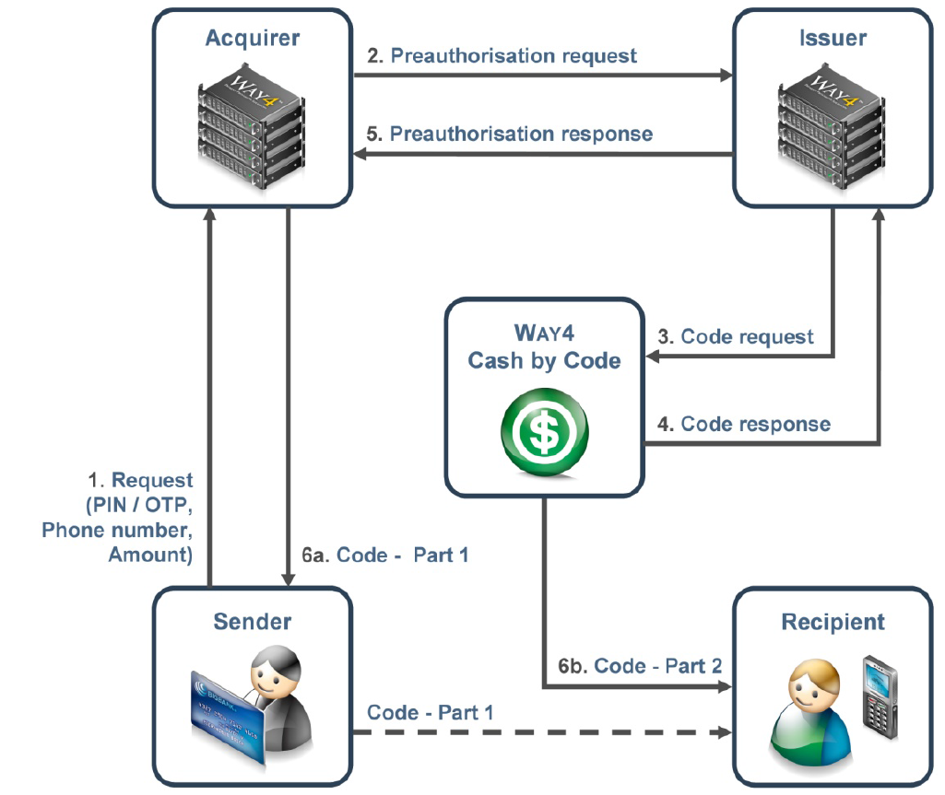

Cardholders can initiate pre-authorisation and code generation requests through an ATM device or using a web-service message (mobile banking, internet banking …)

If using ATM, the cardholder will provide the Card PIN and a few other pieces of information like the amount of money to be sent and the recipient’s mobile phone number.

If using web-service message, the cardholder will be authenticated by the device first, other information like the amount of money needed for the code generation will be input after and sent to the Way4 system.

As a result of the 1st step, a code used to receive cash is generated. The code contains a predefined number of digits and consists of two parts. The first one is printed on the ATM Receipt for the cardholder. The other part is sent in an SMS message to the recipient's phone number.

The code is unique during a given period and has a limited lifetime. Since it is intended for one-time use, the code is blocked and is no longer valid if it has already been used or has expired.

### Code Generation at ATM

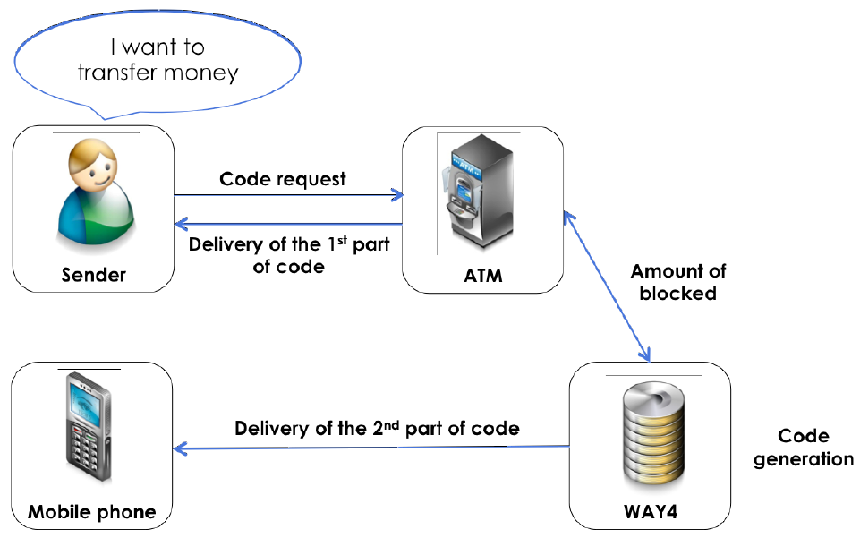

1. Card holder enters the Card and Selects an option to send money at the ATM. The ATM will request the following information from the Card holder
   1. Card PIN
   2. Amount of Money to be Sent (In multiples of minimum denomination supported by the ATM)
   3. Mobile Phone Number of Recipient

The message would be sent to the ATM_CTRL channel on Netserver.

1. The ATM_CTRL channel passes the message to IntraLink adapter to the AuthService channel of Transaction Switch (on-us transaction).
2. The PIN, CVV validation would be performed.
3. AuthService channel would send information to Core Banking System using a special message described later in this document (if source card is debit card). Core Banking checks Account balances and verifies that there is enough money to cover for the Transaction and Fee amount if any. Once the transaction is complete Core Banking will respond with an Approval or a Decline.
4. If everything is validated, then the request would be passed to the Cash By Code service.
5. Cash by code service requires the HSM to generate cash code consisting two parts: OTP1 and OTP2
6. The first part of the Code (OTP1) will be stored in the database alongside with other information (Amount, Currency, Target phone number).
7. The second part (OTP2) would be sent to the recipient by SMS Delivery module through the Way4 Notification.
8. The OTP1 will be printed as the receipt on the ATM, the cardholder then can call and notify recipient of more details of the Transaction including the first part of the code.

### Code Generation by Web-service

Web-service (Way4SOA) is an application running under Way4 application server and supplies SOAP message through HTTP protocol

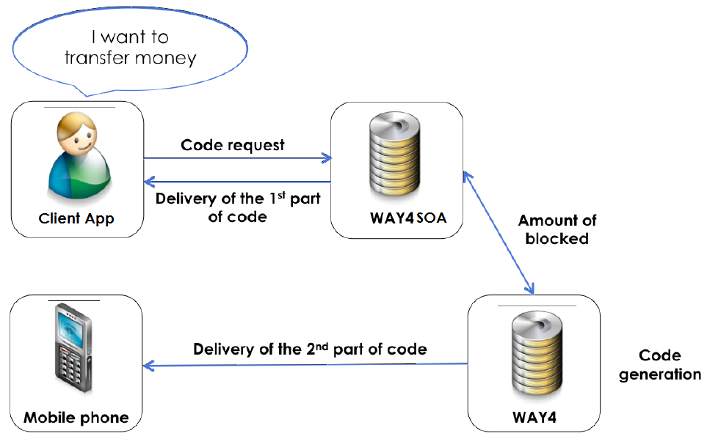

1. To generate code, the client application (web banking, mobile application) after some validations of the application (user, password, etc…), can send the SOAP message to the Webservice application using HTTP protocol.
2. The message would be passed to AcqService on Transaction switch, which then can verify the card base on the information of the card stored in way4card database, then the message is sent to CBS using RBSService for further validations (*if source card is debit card*). When the all the validations passed, the message would be sent to the CashByCode service for code generation.
3. Cash by code service requires the HSM to generate cash code consisting two parts: OTP1 and OTP2
4. The first part of the Code (OTP1) will be stored in the database alongside with other information (Amount, Currency, Target phone number).
5. The second part (OTP2) would be sent to the recipient by SMS Delivery module through the Way4 Notification.
6. The OTP1 will be printed as the receipt on the ATM, the cardholder then can call and notify recipient of more details of the Transaction including the first part of the code.

Sample of the message used to generate cash code and send to the target phone number

Request:

|  |
| --- |
| <?xml version=**"1.0"** encoding=**"UTF-8"**?>  <s:Envelope xmlns:s=**"http://schemas.xmlsoap.org/soap/envelope/"** xmlns:wsin=**"http://www.openwaygroup.com/wsint"**>  <s:Header>  <wsin:UserInfo>**officer="WX_ADMIN"**</wsin:UserInfo>  </s:Header>  <s:Body>  <wsin:AcqCashByCodeToPhone>  <wsin:ContractSearchMethod>**CONTRACT_NUMBER**</wsin:ContractSearchMethod>  <wsin:ContractIdentifier>**4848030097985589**</wsin:ContractIdentifier>  <wsin:SourceContractNumber>**POSCBC**</wsin:SourceContractNumber>  <wsin:Amount>**1000000**</wsin:Amount>  <wsin:Currency>**VND**</wsin:Currency>  <wsin:CashCodePhone>**0978140593**</wsin:CashCodePhone>  </wsin:AcqCashByCodeToPhone>  </s:Body>  </s:Envelope> |

This message create a cash by code transaction for the card “**4848030097985589**” on device “**POSCBC**” with **1,000,000 VND** and the second part of the code will be sent to the phone number “0978140593”.

Response:

|  |
| --- |
| <s:Envelope xmlns:s=**'http://schemas.xmlsoap.org/soap/envelope/'**>  <s:Body>  <AcqCashByCodeToPhoneResponse xmlns=**"http://www.openwaygroup.com/wsint"**>  <AcqCashByCodeToPhoneResult>  <CashCode>**23669**</CashCode>  <CashCodeLifeTime>**86400**</CashCodeLifeTime>  <RRNOut>**814519009010**</RRNOut>  <AuthCode>**996066**</AuthCode>  <RetCode>**0**</RetCode>  <RetMsg>**Successfully completed**</RetMsg>  </AcqCashByCodeToPhoneResult>  </AcqCashByCodeToPhoneResponse>  </s:Body>  </s:Envelope> |

The first part of the code is “**23669**” and lives within 24 hours (86400s).

Web service can be used for mobile banking and web banking applications.

## Card-less Cash Withdraw at an ATM

This is the 2nd Stage in sending/receiving money using WAY4 Cash by Code.

After receiving the second part of the code, the recipient has a limited time interval (defined by the code lifetime) to receive the first part from the sender and use the whole number to get cash via an ATM.

The recipient specifies the whole code and amount in a request. If the operation pre-authorisation is found, the code and amount are correct, and the pre-authorisation has not expired, then recipient gets the money.

### Message Flow

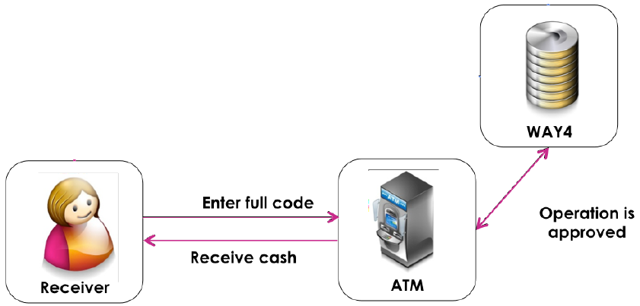

1. Recipient selects a soft key on the ATM to initiate Card-less transaction. The ATM will request the following information from the Recipient
   1. Amount of Money and the currency to be withdrawn
   2. Code (Complete Code, OTP1 and OTP2 combined)
2. ATM sends the entered information to the ATM_CTRL channel on Netserver.
3. The message then be passed to the cash by code service on transaction switch through Intralink Adapter.
4. The information stored in the database will be selected and pass to the HSM for OTP 2 generation.
5. The cash by code service then perform the validation of the entered information and the stored information.
6. Once all the information is validated, the response is passed from the WAY4 Cash by Code service to the ATM_CTRL.
7. The ATM_CTRL will send a message to CBS to debit the client account (*if source card is debit card*).
8. The ATM_CTRL will send an approval message (or decline message) to the ATM.
9. The ATM will then dispense CASH to the recipient (or will display a message stating that this Transaction cannot be completed)
   1. The ATM would also print a receipt of the amount withdrawn
   2. Transaction will be rejected in case of low notes. No partial dispensing will be allowed in case of insufficient notes.
   3. If there is a device fault, if the ATM generates a Reversal, then WAY4 will reverse the Cash withdrawal request and mark the status of transactions as Active and Not Completed.
   4. In a case where for some other reason the request is rejected and WAY4 receives a reversal, then WAY4 will reverse the Cash withdrawal request and mark the status of transactions as Active and Not Completed.
10. The Transaction will be marked as completed in WAY4. The Cash Withdrawal Date and Time will be logged and linked to the Original Transaction.

### ATM Limitation

The Remittance amount entered at the ATM during sending money will be validated to ensure that it is dispensable at an ATM. The logic used will be as follows:

* The Amount will have to be fully divisible by the smallest denomination supported in the ATM Configuration in WAY4
  + For Example Money is being sent from XYZ to VietNam and the denominations supported in VietNam are 5000, 10000, 20000 and 50000.
  + In this case the amount entered will have to be fully divisible by the lowest denomination of VietNam which is 5000, else the transactions will be declined
* The Amount cannot be greater than the Highest Denomination * 40, where 40 is the maximum number of notes which can be dispensed by an ATM.
  + For example, the highest denomination is 50000 in VietNam.
  + Thus the Amount cannot be greater than 50000*40, which is 2,000,000

# Way4 Cash by Code Product Configuration

## Transaction Fees

Fee for the cash-by-code transaction would be considered as miscellaneous fee (fee not attached alongside with the transaction). When perform the code generation transaction, the fee will be charged instantly to the account.

Reversal of the unexpired authorization will not reverse the fee.

OCB want to setup fee for this transaction as below:

## Usage Limiters

A new transaction type Cash Dispense (Cardless) is use for the cash-by-code transactions. Thus, we can configure usage limiters for this kind of service.

The limiters can be configured in both the service packages of device and card contract, which allow to setup some limitation for the transactions (the maximum amount of transactions made, the max single amount, etc …)

# Way4 Cash by Code Monitoring

## Authentication Monitoring

The authentication information for the cash-by-code transaction would be stored in the database and we can manage using authentication module:

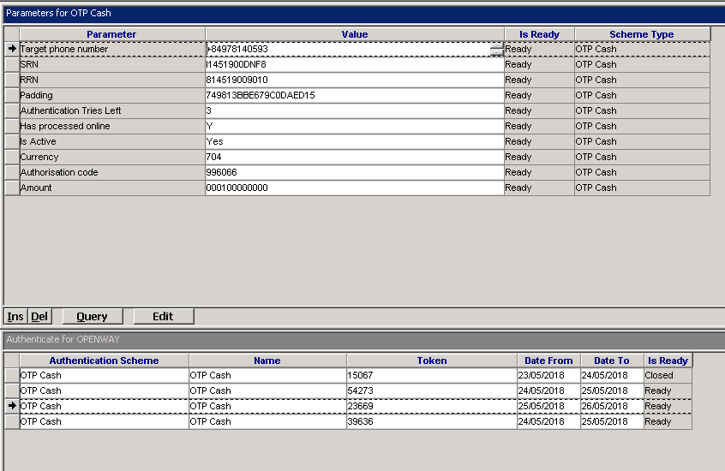

The second part of the code generated by the WAY4 Cash by Code module is never saved in the Database.

## Transaction Reversal

Way4 allows listing all the cash-by-code transactions of a card using form (all doc), then create a reversal for that transaction when there is no financial document received.

Way4 supplies an API allow to reverse a cash-by-code authorization transaction when the cash code is still active.

Sample of the reversal SOAP message.

Request:

|  |
| --- |
| <s:Envelope xmlns:s=**"http://schemas.xmlsoap.org/soap/envelope/"** xmlns:wsin=**"http://www.openwaygroup.com/wsint"**>  <s:Header>  <wsin:UserInfo>**officer="WX_ADMIN"**</wsin:UserInfo>  </s:Header>  <s:Body>  <wsin:AcqCashByCodeToPhoneRev>  <wsin:ContractSearchMethod>**CONTRACT_NUMBER**</wsin:ContractSearchMethod>  <wsin:ContractIdentifier>**4848030097985589**</wsin:ContractIdentifier>  <wsin:SourceContractNumber>**POSCBC**</wsin:SourceContractNumber>  <wsin:Amount>**1000000**</wsin:Amount>  <wsin:Currency>**VND**</wsin:Currency>  <wsin:RRN>**814519009010**</wsin:RRN>  </wsin:AcqCashByCodeToPhoneRev>  </s:Body>  </s:Envelope> |

Response:

|  |
| --- |
| <s:Envelope xmlns:s=**'http://schemas.xmlsoap.org/soap/envelope/'**>  <s:Body>  <AcqCashByCodeToPhoneRevResponse xmlns=**"http://www.openwaygroup.com/wsint"**>  <AcqCashByCodeToPhoneRevResult>  <RRNOut>**814519009010**</RRNOut>  <AuthCode>**996066**</AuthCode>  <RetCode>**0**</RetCode>  <RetMsg>**Successfully completed**</RetMsg>  </AcqCashByCodeToPhoneRevResult>  </AcqCashByCodeToPhoneRevResponse>  </s:Body>  </s:Envelope> |

After reversal successful, the cash code would be not active and the blocked amount would be unblocked from the cardholder’s account.

## Transaction Expiry

In case the Card-less Cash Withdrawal Transaction does not happen within a specified Time Interval which is a configurable parameter, then the transaction is marked as Expired.

After code expired, operator can query the expired authorization doc and create a reversal for the doc to unblock the amount of the account.

We can set a parameter AUTH_SAVING_PERIOD = <number of days> for the transaction type which means if no financial document received for the authorization doc after that number of days, the amount would be unblocked using standard procedure “Clear Old Pendings”.

# Core Banking System Interface

## Message Specification

The following message will be used to integrate with Core Banking System